Pee Dee Union Baptist Church
92 Chestnut Street
Cheraw, South Carolina 29520
PASTORAL VACANCY ANNOUNCEMENT

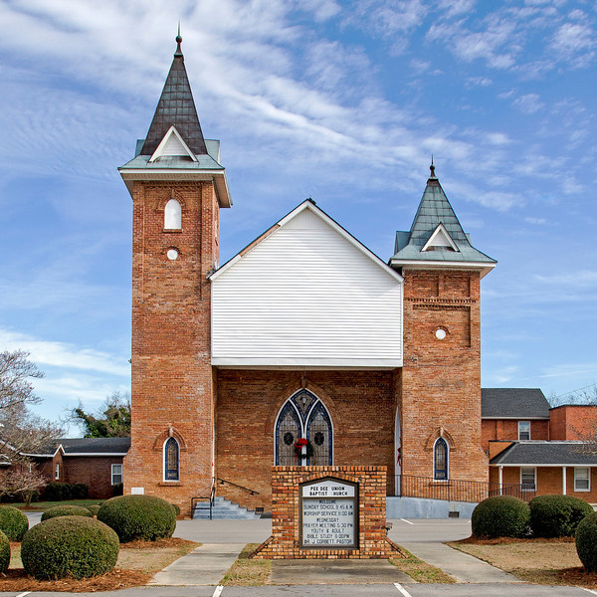

The Pastoral Search Committee, representing the membership of Pee Dee Union Baptist Church (PDUBC) is seeking a fulltime Pastor called by God to serve as the spiritual leader of the congregation.
Church History
On January 12, 1782, Cheraw Hill Baptist Church had its constitution granted by the Welch Neck Baptist Church, Society Hill, SC. The church consisted of both black and white members. By the 1860’s, the black members had become the majority, and they ultimately applied for and received letters of dismissal from the church. Twenty-three (23) letters were granted immediately, and this was the beginning of Pee Dee Union Baptist Church. It was founded just a few yards from the original Cheraw Hill Baptist Church, and in January 1867, the Rev. Wisdom London, founder, preached the first message from a platform built outdoors. In December 1867, two hundred eighty-five (285) blacks applied for and received letters to join Pee Dee Union Baptist Church. Through true sacrifices, the first wooden building was constructed to house the growing congregation. That structure was destroyed in March 1912 by a tornado, and the present structure was rebuilt on the same parcel of land in 1912 and dedicated in March 1913. For nearly one hundred (100) years, this marvelous structure has served as home for the congregation. In its one hundred forty-nine (149) years in existence, Pee Dee Union has had the following twelve (12) men serve as Pastor: Rev. Wisdom London, Rev. Claudius McCall, Rev. Woodard, Rev. Sidney Johnson, Rev. Alfred McPhail, Rev. Isaiah Williams, Rev. F. W. Prince, Rev. J. N. Carr, Rev. O. St. Clair Franklin, Rev. James Levy, Rev. Dr. Thomas Dawkins, and Rev. Dr. Jerry Corbett. The church continues to serve as a strong force in the community and provides diverse ministry for all people.
Personal/Professional Qualifications
The Pastor:
- Shall meet the qualifications as in 1 Timothy 3:1-7 and Titus 1:7-9
- Must be an ordained Baptist minister of the gospel, whose Christian and moral character are beyond question
- Must possess administrative and leadership skills
- Must have a minimum of a BA/BS degree from an accredited institution of higher learning preferably a Master’s Degree from an accredited Seminary or Divinity School. Candidates who fail to meet these requirements will be viewed on a case-by-case basis.
- Must have a minimum of five (5) years’ experience as senior pastor
- Must have proficient knowledge of Baptist doctrine, church policies and procedures
- Should be preferably married
- Must be willing to work with all age groups of the church
Pastoral Responsibilities
WORSHIP SERVICES
- Preaches (prepares and delivers relevant, spirit-filled sermons)
- Worship Leadership (plans and conducts worship services)
- Administers Baptism and Communion
- Officiates at weddings, funerals, baby dedications, etc.
TEACHING/TRAINING
- Teaches Bible study and other Christian Education training
- Trains church leaders and spiritual growth of all members
- Provides leadership in evangelistic, ethical or discipleship concerns and issues
- Counsels pre-marital/marital concerns of church members
PASTORAL CARE
- Counsels church members spiritually
- Visits sick/ shut-ins and bereaved church members
- Is responsible for all other duties related to serving the congregation spiritually and administratively
ADMINISTRATION
- Oversees daily work functions of the church staff
- Serves as ex-officio member of all ministries, committees and church organizations
- Is responsible for the pulpit ministry in his/her absence and in cooperation with the Board of Deacons, arranges for pulpit occupancy
- Moderates and presides at church business meetings, Executive Board and other meetings, as needed
- Appoints (with assistance from Board of Deacons) members to the budget, audit and other standing and special committees, with the church’s approval

The following information must be provided by all applicants:
- A cover letter (why you are interested in PDUBC, etc.)
- Completed Pee Dee Union Baptist Church job application (included)
- Copy of your ministerial license(s) and ordination certificate
- Copy of theology training and degree(s)
- Current resume’
- Current photo of yourself
- Copy of CD/DVD of recent sermon
- Three signed letters of recommendation (clergy, professional, personal)
Do not list family members or relatives as references.
- Deadline to submit the entire application package is May 31, 2016. Applicants who fail to adhere to this deadline or send incomplete packets will not be considered for the position.

Send all information to:
Pee Dee Union Baptist Church
Pastoral Search Committee
C/O Deacon James N. Sweeney, Chairperson
2350 W. Market Street Extension
Cheraw, South Carolina 29520
(843) 537-4663

All information submitted will be treated in a confidential manner. Additional information may be requested and/or required.
Final candidates will be asked to consent to a reference check, full background screening (criminal history, drug test and credit check), to include a doctor’s letter stating general health. The Pastoral Search Committee will acknowledge receipt of all candidate responses that are submitted to us on a timely basis. Candidates who are accepted for consideration will be notified and sent additional instructions and information.

PEE DEE UNION BAPTIST CHURCH PASTOR APPLICATION FORM
PERSONAL INFORMATION: DATE
Name:
Present address:
How Long: Birth Date:
Telephone: ( ) Business ( ) Cell ( )
Email Address: Personal website address (if available)
If hired, can you present proof of your legal right to live and work in this country? YES NO N/A
Marital Status: Married Separated Divorced Widowed Single
If married, name of spouse:
Is this your first spouse? YES NO
Names and ages of children:

Are you ordained? YES NO Date and place of Ordination:
Denomination:
Are you interested in relocating to Cheraw, SC if selected? YES NO
EDUCATION BACKGROUND
TYPE OF SCHOOL NAME OF SCHOOL LOCATION No. of YEARS
COMPLETED
College/University:
Vocational or
Technical Schools:
Graduate School:
Other:
Please provide copy of diploma/certificate for education completed
Additional Academic Experience (post-secondary)
Please list any courses attempted and whether or not completed; P/T or F/T: dates, institutions and awards received.

Please briefly describe your general background: summarize your ministry strengths and weaknesses; ministry preferences and vision; and your special interests in ministry. (Attach additional pages if necessary.)

[If you answer “Yes” to any of the questions in the following section, please attach a separate sheet indicating the nature of the suit, offense, date, court, and disposition or other appropriate explanation. A conviction record will not automatically be a bar from employment. Factors such as your age at the crime of the crime, seriousness and nature of the violation, time elapsed since the crime, job relatedness, and subsequent rehabilitation will be considered.]
- Are you presently being investigated or under a procedure to consider your discharge for misconduct by your present employer? No Yes

- Has any employer ever subjected you to disciplinary action, suspended, terminated, or asked you to leave a job or volunteer position on the grounds of any unlawful sexual behavior, or violation of an employer’s sexual misconduct or harassment policy? No Yes

- Have you ever been charged in a civil or criminal proceeding with improprieties regarding children?
No Yes

- Have you ever entered a guilty plea, a plea of “no contest” (nolo contendere), or has any court ever deferred further proceedings without entering a finding of guilty and placed you on probation or in a public service education program for any crime other than a minor traffic offence? No Yes

- Have you ever been suspended, discharged, or resigned in lieu of discharge from any position?
No Yes

- Have you ever filed bankruptcy? No Yes
If yes, please state the date, nature and circumstances of the bankruptcy:
- Have you ever been arrested or convicted for any offence? No Yes If yes, please state the nature of the crime(s), when and where convicted and disposition of the case:

- Have you been treated for substance abuse? No Yes

- Have you ever been a plaintiff or defendant in an administrative, civil matter or lawsuit? No Yes
WORK EXPERIENCE
Please list your work and/or ministry experience for the past five years beginning with you most recent job held. If you were self-employed, give firm name. Attach additional sheets if necessary.
Name of Employer: Name of last supervisor:
Address: Employment dates:
Phone number: From: to
Your last job title:
Reason for leaving (be specific):
May we contact this employer for a reference? YES NO
Name of Employer: Name of last supervisor:
Address: Employment dates:
Phone number: From: to
Your last job title:
Reason for leaving (be specific):
May we contact this employer for a reference? YES NO
Name of Employer: Name of last supervisor:
Address: Employment dates:
Phone number: From: to
Your last job title:
Reason for leaving (be specific):
May we contact this employer for a reference? YES NO
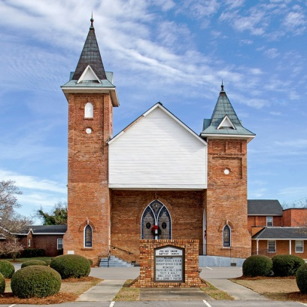
What evidence is there that you were able to operate cross-culturally and be at home in a multi-cultural community? What experience do you have in a multi-cultural community?

Military History: ? YES NO If yes, provide Long Form DD214.
Membership and Participation in Educational and Civic Organizations:

List of honors you have received:

LEADERSHIP ROLES

Leadership of a church involves several roles. Consider the following list (Note up to five)
CHURCH LEADERSHIP RESPONSIBILITIES:
General Pastoral Care
Oversight and coordination of day-to-day operations of the church
Preaching
Youth Ministry
Training, Counseling, Teaching, Mentoring and Confidentiality
Outreach to the wider community
Support and oversight of staff and volunteers (leaders and coordinators of various activities)
Collaborative decision making in boards or committees
Networking, facilitating partnerships, promoting unity and growth
Evangelism
Visiting the sick and bereaved

In which of these are you the strongest? Explain.

In which of these are you the weakest? Explain.

What evidence is there to confirm that you have strengths in these?

AGREEMENT (PLEASE READ CAREFULLY BEFORE SIGNING)
Please Read Carefully, Initial Each Paragraph and Sign Below
Initials:
I certify that all the information in this application is accurate and complete to the best of my knowledge and I have not knowingly withheld and information that might adversely affect my chances for employment. I understand that misleading or false information will constitute sufficient cause for refusal of hire or termination of my employment.

Initials:
I understand that neither the acceptance of this application nor the subsequent entry into any type of employment relationship with Pee Dee Union Baptist church creates an actual or implied contract of employment. I understand that, if I accept employment with Pee Dee Union Baptist Church, it will be on an at-will basis. This means that wither Pee Dee Union Baptist Church or I have the right to terminate the employment relationship at any time, for any reason, with or without cause.

Signature of applicant: Date:

